# “PROJECT TITLE”

### A Project report submitted

**In the partial fulfillment the award of degree of**

**BACHELOR OF TECHNOLOGY**

**IN**

**COMPUTER SCIENCE AND ENGINEERING (2022-2023)**

**BY**

**A.Dhanush Reg.no.211801360004**

**Under the esteemed Guidance of**

**Mrs. G. Rama Devi, M.Tech,(Ph.d),Asst. Professor**

**CENTURION UNIVERSITY SCHOOL OF ENGINEERING AND TECHNOLOGY**

**Rollavaka village, Tekkali mandal 535003**

**(2022-2023)**

##### CENTURION UNIVERSITY OF TECHNOLOGY AND MANAGEMENT

##### DEPARTMENT OF COMPUTER SCIENCE AND ENGINEERING

**ANDHRA PRADESH**

**(2020-2025)**

BONAFIDE CERTIFICATE

##### **This is to certify that the project work entitled** “ADVANCED INTELLIGENT TOURIST GUIDE” **is a fulfillment of project work done by** A.Dhanush (Reg.No.211801360004) **for the award the degree of** BACHELOR OF TECHNOLOGY **in** COMPUTER SCIENCE AND ENGINEERING, CENTURION UNIVERSITYOF TECHNOLOGY AND MANAGEMENT**, during the academic year** 2022-2023**.**

##### INTERNALGUIDE HEAD OF THE DEPARTMENT

##### Mrs .G. Rama Devi Mr.R. Lakshmana Rao

**Asst. Professor Asst. Professor**

**Dept. of CSE Dept. of CSE**

**EXTERNAL EXAMINER**

**ACKNOWLEDGEMENT**

It is with at most pleasure and excitement we submit our project partial fulfillment of the requirement for the award of Bachelor of Technology.

The project is a result to the cumulate efforts, support, guidance, encouragement and inspiration from many of those for whom we have to give our truthful honor and express gratitude through bringing out this project at the outset as per our knowledge.

I convey my special thanks to our project **Guide Mrs. G. Rama Devi(Asst. Professor)** who has guided, encouraged and tremendously supported me to enhance my knowledge with present working of this project to bring out enriching the quality of project.

I express my appreciativeness to **Mr. R.LAKSHMAN RAO(Asst. Professor) and Head of the Department,** who facilitated us to providing the friendly environment which helped to enhance my skills in present project.

I would also like to extend my gratitude to **Dr. K. V. G. KRISHNA MURTHY, Dean-School of Engineering And Technology, Centurion University of Technology and Management** who has helped us to attain all the requirements of the project.

I convey my sincere thanks to **Dr. RAMANA RAO, Ph. D Registrar of Centurion University of Technology and Management** who provided us with an opportunity to take on project work in well-equipped laboratories of Computer Science Department in our college.

At the outset, we thank to **Sri. G.S.N.RAJU**, beloved **Vice Chancellor of Centurion University of Technology and Management** who is the back bone by providing for completion of this project, Thank you sir.

**DECLA****RATION**

I hereby declare that the project entitled **“PROJECT TITLE”** submitted to the fulfillment of award the degree of **B.TECH (CSE)** in **CENTURION UNIVERSITY OF TECHNOLOGY AND MANAGEMENT**, **ANDHRA PRADESH.**

A Dhanush 211801360004

Table of Figure(s) 4

1. Introduction 5
   1. Purpose 5
   2. Scope 5
   3. Definitions, Acronyms and Abbreviations 5
   4. References 6
   5. Overview 6
2. Overall Description 6
   1. Product Perspective 6
      1. System Interface 6
      2. User interface 6
      3. Hardware Interface 6
      4. Software Interface 7
      5. Communication Interfaces 7
      6. Memory Constraints 7
      7. Operations 7
      8. Site Adaption Requirements 7
   2. Product functions 8
      1. Context Diagram 8
      2. Use Case Diagrams 8
      3. Use case descriptions /Introductions 13
   3. User Characteristics 16
      1. Students 16
      2. Professors 16
      3. System Administrators 16
   4. Constraints 16
      1. User Interface Constraints 16
      2. Hardware Constraints 17
      3. Software Constraints 17
      4. Data Management Constraints 17
      5. Operational Constraints 17
      6. Site Adaptation Constraints 17
      7. Design Standards Compliance 17
   5. Assumptions and dependencies 17
   6. Apportioning of Requirements 17

Integration of LDAP login might be apportioned to future versions 17

1. Specific Requirements 18
   1. External interface 18
      1. Web Server 18
      2. PHP Application 18
      3. MySQL Database 18
   2. Functional Requirements 18
      1. Use Case Scenario 18
   3. Performance Requirements 25
   4. Logical database requirements 25
   5. Design Constraints 25
   6. Software System Attributes 25
      1. Reliability 25
      2. Availability 25
      3. Security 26
      4. Maintainability 26

Portability 26

1. **Introduction**
   1. **Purpose**

The purpose of the Advanced Tourism website is to provide a better platform to the tourists across the globe. The website should include features such as tourism booking, virtual display of places,information of tourist places and famous monuments across the globe. The website should also provide a user-friendly interface for tourists and instructors to access and manage their accounts. The ultimate goal of the website is to provide a quality information about tourism places and ticket booking is made accessed easy.

* 1. **Scope**

This software system will be an advanced tourist website for users. It provides the communication between website and users. More specially to design and develop a easy interface between them. It helps to find their local and as per their required places. It is most required for the those who are want to find their trip intelligently and efficiently. It also helps to them who want their trip effortless.

* 1. **Definitions, Acronyms and Abbreviations**
     1. **Tourism website**

Tourism website means it a software meant to help different type of people to find their desire places which are available in the website . It helps in guiding the people.

* + 1. **Administrator**

Course administrator is a user who can control the entire website. He can modify the website or change the movements of the website .

* + 1. **User**

An user means who want to access information on tourism website. He can only access information and book tickets but cannot save changes to the website

* + 1. **Portal**

An portal is the main page in the website. Here we can see and access the information and book tickets**.**

* 1. **References**

1. Tripadvisor.com
2. Gettyourguide.com
3. Chat Gpt for queries
   1. **Overview**

This is a working document and, as such, is subject to change. In its initial form, it is incomplete by definition, and will require continuing refinement. Requirements may be modified and additional requirements may be added as development progresses and the system description becomes more refined. This information will serve as a framework for the current definition and future evolution of the Advanced tourism website .

1. **Overall Description**
   1. **Product Perspective**

My advanced tourism website meet to provide a interface for those who want to make trip easier and effortless.

* + 1. **System Interface**

. The user inputs data via the web server using HTML forms. The actual program that will perform the operations is written in HTML and CSS

* + 1. **User interface**

The new system shall provide a very intuitive and simple interface to the users, so that the user can easily navigate through the website

* + 1. **Hardware Interface**

1. Server side

The web application will be hosted on a web server which is listening on the web standard port, port 80.

1. Client side

Monitor screen – the software shall display information to the user via the monitor screen

Mouse – the software shall interact with the movement of the mouse and the mouse buttons. The mouse shall activate areas for data input, command buttons and select options from menus.

Keyboard – the software shall interact with the keystrokes of the keyboard. The keyboard will input data into the active area of the data.

* + 1. **Software Interface**
       1. Server side

An web server will accept all requests from the client and forward it accordingly. A database will be hosted centrally using MySQL.

* + - 1. Client side

An OS which is capable of running a modern web browser which supports JavaScript and HTML5.

* + 1. **Communication Interfaces**

The HTTP or HTTPS protocol(s) will be used to facilitate communication between the client and server.

* + 1. **Memory Constraints**

Memory constraints will come into play when the size of MySQL grows to a considerable size.

* + 1. **Operations**

The product shall have operations to protect the database from being corrupted or accidentally altered during a system failure.

* + 1. **Site Adaption Requirements**

Not applicable

* 1. **Product functions**
     1. **Context Diagram**

**Context Diagram**

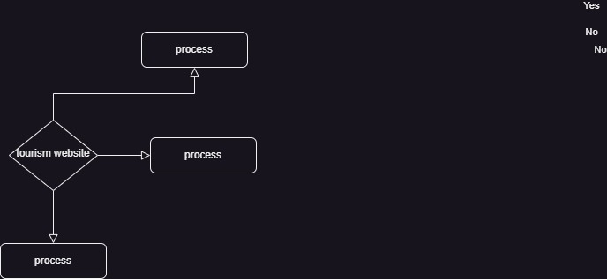

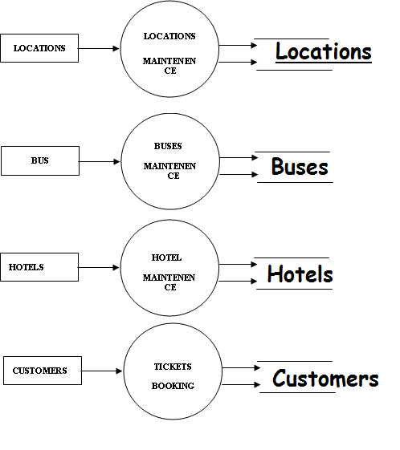

**CONTEXT DIAGRAM OF TOURISM WEBSITE**

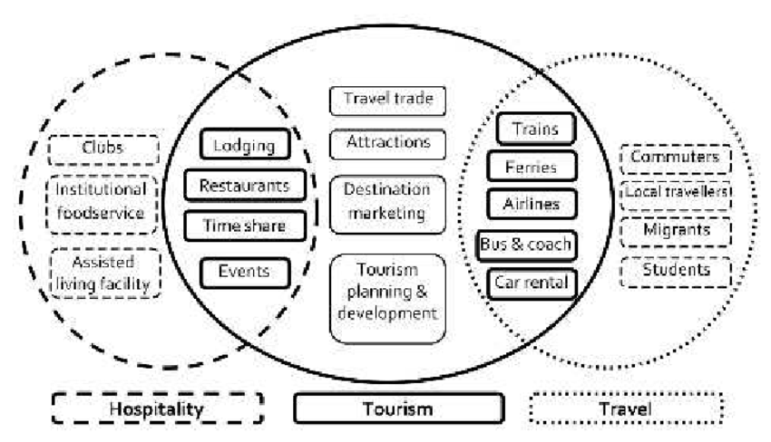

**User Case Diagrams**

* + - 1. **User Login**

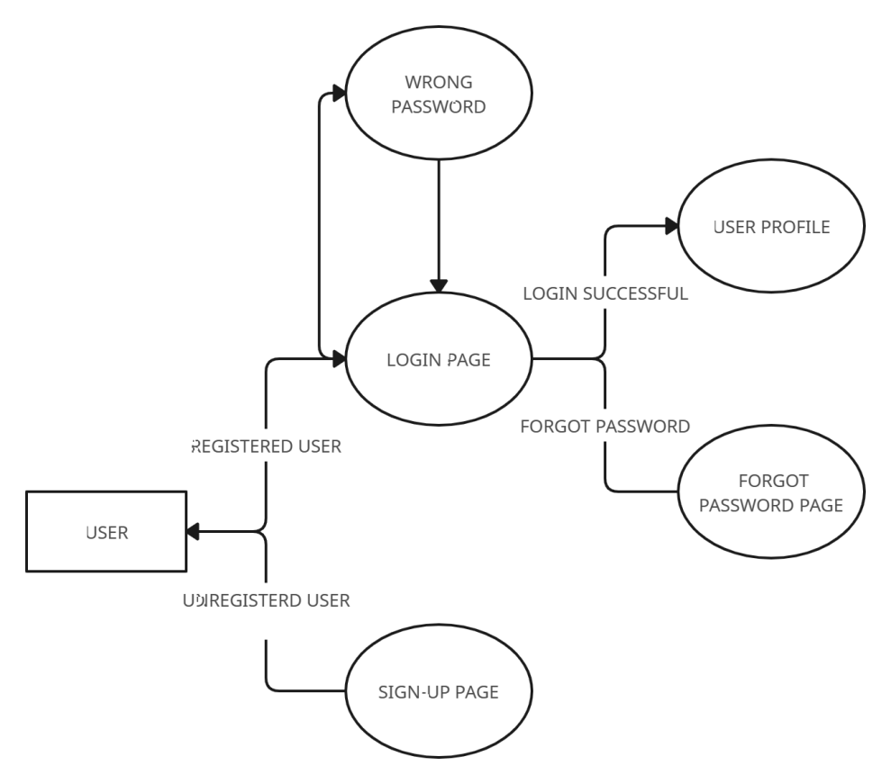

* 1. **User Characteristics**
     1. **Users**

Users are the primary consumers of an tourist portal. They access information posted by administration, book tickets and read blogs and many more

* + 1. **Bloggers**

Blog is an important part in a website development. The information provided by blogs are useful to the users to select their designed places and bloggers are the most important part to provide that.

* + 1. **System Administrators**

System administrator will

* 1. **Constraints**
     1. **User Interface Constraints**

Using this system is fairly simple and intuitive. A user familiar with basic browser navigation skills should be able to understand all functionality provided by the system.

* + 1. **Hardware Constraints**

The system should work on most home desktop and laptop computers which support JavaScript and HTML5.

* + 1. **Software Constraints**

The system will be intended to run on Firefox 4 and above, Google Chrome 10 and above and Internet Explorer 8 and above.

* + 1. **Data Management Constraints**

System shall be able to interface with other components according to their specifications.

* + 1. **Operational Constraints**

The system is limited by its operating server in terms of the maximum number of users it can support at a given time.

* + 1. **Site Adaptation Constraints**

The component will be adapted to the overarching system at the conclusion of the system creation.

* + 1. **Design Standards Compliance**

The system shall be implemented in HTML/CSS.

* 1. **Assumptions and dependencies**

Most of the training portals have a lot of redundant features which are rarely used in an academic sessions. Our new system focuses on the features which are most important to the users of an training institute along with introduction of some new features which other portals lacks.

1. **Specific Requirements**
   1. **External interface**
      1. **Web Server**
         * Apache will be used as web server:
         * The user inputs data via the web server using HTML forms
         * The web server executes the HTML as a module and HTML script retrieves the post data if available.
         * The web server receives information back from the HTML script.
         * The web server displays a HTML page as result to the end-user.
      2. **HTML Application**

The actual program that will perform the operations is written in HTML. All data will be stored in a database.

* + 1. **MySQL Database**

It’s an open source SQL database to store all data which communicates with the application on the server.

* 1. **Functional Requirements**
     1. **Use Case Scenario**
        1. **Use Case Scenario 1 – User Login**

|  |  |
| --- | --- |
| **User Login** | |
| **Purpose** | User logs in to system using existing profile. |
| **User** | A user with an existing profile. |
| **Input Data** | Profile username and password. |
| **Output Data** | Corresponding page data. |
| **Invariants** | Profile table data and user information. |
| **Pre-conditions** | User is not logged in to a profile, input profile exists in data base, user password matches profile |
| **Post-conditions** | User's computer has been supplied with appropriate cookie, page data is appropriate for selected profile |
| **Basic Flow:** | Webpage looks up profile data and returns the matching cookie. Webpage is updated to match new user data. |
| **Alternative Flow(s):** | Invalid password, invalid username, or mismatched username and  password redirect to error message and previous page. |
| **Business Rules:** | This allows users to log in to their profile from anywhere. |

* + - 1. **Use Case Scenario 2 – User checking for trainer**

A user logs into the system and he will search for the tourism package and time du

**User checking for trainer**

|  |  |
| --- | --- |
| **Purpose** | A user will search for the tourism package |
| **User** | A legitimate user logged into the system |
| **Input Data** | He will enter the location details |
| **Output Data** | If there is any tourist places are available it display the places details. |
| **Invariants** | The location details. |
| **Pre-conditions** | User is Logged in; file exists on user's computer. |
| **Post-conditions** | The system will check for the tourist places in that location. |
| **Basic Flow:** | The user login into their account .He will enter the location details and click on the search button. The system will check for the tourist place regarding to user requested location. If any places are available it display the place information. |

**Use Case Scenario 3 – Admin works**

A admin will accept or reject the user requests.

**Admin works**

|  |  |
| --- | --- |
| **Purpose** | A admin will accept or reject the user requests |
| **User** | Admin that website. |
| **Input Data** | Admin login credentials. |
| **Output Data** | Accepts and rejects of user requests |
| **Invariants** | Permissions. |
| **Pre-conditions** | User is logged in and the file must be  shared with him or with the group which he is a member of. |
| **Post-conditions** | The user has downloaded the file successfully. |
| **Basic Flow:** | User logs in, selects the file which he wants to download. The file is then  transferred from the server to the user’s computer. |

**Performance Requirements**

The system should support at least 150 concurrent users.

This statement provides a general sense of reliability when the system is under load. It is important that a substantial number of users be able to access the system at the same time, since an academic portal is important to the courses that employ it. The times when the system will be under the most stress are likely during assignment submissions. Therefore, it must be able to handle at least 150 concurrent users.

* 1. **Logical database requirements**

All data will be saved in the database: user accounts and profiles, discussion data, messages etc. (except files which are stored on the disk.) The database allows concurrent access and will be kept consistent at all times, requiring a good database design.

* 1. **Design Constraints**

1. The communication between the portal software and the database will be in SQL.
2. The portal layout will be produced with HTML/CSS.
3. The product will be written in PHP.
4. The output must be compatible with W3C XHTML 1.0
5. The source code must follow the coding conventions of PHP.
6. System administrators must have access to comprehensive documentation.
   1. **Software System Attributes**

The software consists of the following elements:

1. The web server
2. The HTML/CSS application
3. The MySQL database.
   * 1. **Reliability**

The reliability of the overall program depends on the reliability of the separate components.

* + 1. **Availability**

The system should be available at all times, meaning the user can access it using a web browser, only restricted by the down time of the server on which the system

runs. In case of a of a hardware failure or database corruption, a replacement page will be shown. Also in case of a hardware failure or database corruption, backups of the database should be retrieved with the MySQL server and saved by the administrator.

* + 1. **Security**

1. Passwords will be saved encrypted in the database in order to ensure the user's privacy.
2. The user's IP will be logged.
3. The system will be protected against vulnerabilities such as SQL injection attacks.
   * 1. **Maintainability**

MySQL is used for maintaining the database and the Apache server takes care of the site. In case of a failure, a re-initialization of the program is recommended.

* + 1. **Portability**

The application is Linux-based and should be compatible with other systems. Apache, PHP and MySQL programs are practically independent of the OS-system which they communicate with. The end-user part is fully portable and any system using any web browser should be able to use the features of the application.